# **Ansible Usecase – Linux Patch Update**

**PlayBook Code** : Linux-Update.yml

---

- name: Update Linux

hosts: web

become: yes

become_user: root

gather_facts: true

tasks:

- name : Updating Linux

yum:

name: '*'

update_cache: yes

download_only: no

state: latest

- set_fact:

check_Category: "{{ansible_hostname | type_debug}}"

- debug:

msg: 'Variable "ansible_hostname" with value "{{ansible_hostname}}" have category "{{check_Category}}"'

...

Run Playbook Command :



Output :

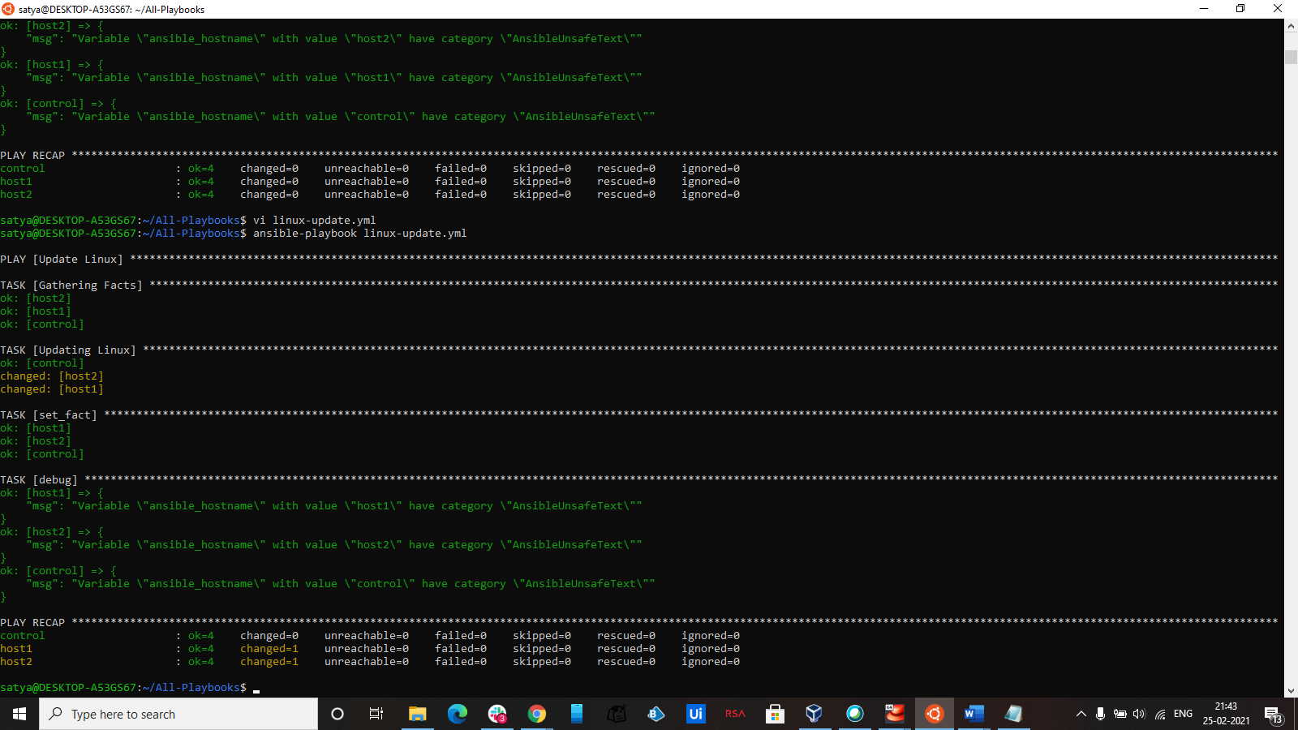

**Note** : Please make Sure the Indendation is Correct